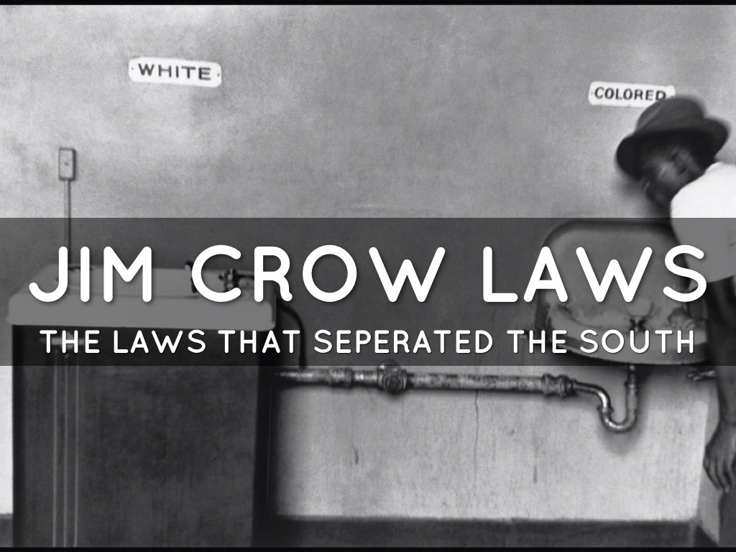Jim Crow laws were state and local laws enforcing racial segregation in the Southern United States. Enacted after the Reconstruction period, these laws continued in force until 1965. They mandated racial segregation in all public facilities in states of the former Confederate States of America, starting in 1890 with a "separate but equal" status for African Americans. Facilities for African Americans were consistently inferior and underfunded compared to those available to white Americans; sometimes they did not exist at all. These Jim Crow laws followed the 1800–1866 Black Codes, which had previously restricted the civil rights and civil liberties of African Americans.
In the United States, the Black Codes were laws passed by Southern states in 1865 and 1866, after the Civil War. These laws had the intent and the effect of restricting African Americans' freedom, and of compelling them to work in a labor economy based on low wages or debt. Black Codes were part of a larger pattern of Southern whites trying to suppress the new freedom of emancipated African American slaves, the freedmen.
- Name 5 public places that you believe would follow the Jim Crow Laws

- Define Jim Crow Laws and what type of penalties could be imposed for law breakers?

- What types of freedoms would be restricted by the Black Codes?

- For roughly how many years did the Jim Crow Laws last in the South?

